*Tableau Dashboard Documentation*

*- Team members:* Anh Quan Hua (Project Lead)

Nithini Bogahawattha

Xiaolu Li

Gouri Nandan Reddy Gangavaram

# 1. Introduction

*Definitions*: Tableau Dashboards are compact views consisting of many different visualizations that aim to help users to quickly grasp the main insights to be showcased. Since the analysis report contains visualizations that might not be easily interpret to a wide range of viewers, our Tableau Dashboards are created to highlight different answers to frequently asked topics.

*Implementation*: With how our datasets are structured, it is crucial to clean the data to remove null and misleading data before using it. In this documentation, we will provide in-depth details to the formation of the Dashboards.

*Future use cases*: Tableau Dashboards are the basis of Dashboards Templates. Tableau allows users to replace the data source of its workbook. This allows for existing Tableau Dashboards to function as Templates as long as new data follows the same structure as the data being replaced.

*Data sources:* Fitness Track Products E-commerce:

<https://www.kaggle.com/datasets/devsubhash/fitness-trackers-products-ecommerce>

Calories Burnt during Exercises & Activities Data:

<https://www.kaggle.com/aadhavvignesh/calories-burned-during-exercise-and-activities>

# 2. Dashboard

## a. Top Competitors Overview Dashboard – Anh Quan Hua

**Aim of the dashboard:**

This dashboard aims to provide clear insights to how the top company are being received in a particular market. It answers questions such as: What is the average selling price for each of the brands, how much coverage are each company getting and what is the average ratings for the top sellers.

**Link to the public dashboard:**

<https://public.tableau.com/app/profile/quan.h5693/viz/FitnessWearablesWorkbook/TopBrandsDash>

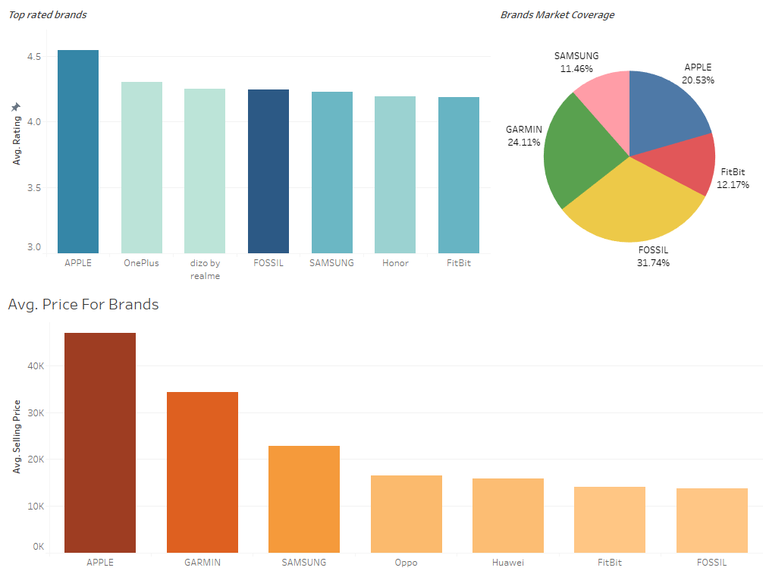

**Data used:**

<https://www.kaggle.com/datasets/devsubhash/fitness-trackers-products-ecommerce>

**Data Pre-processing:**

After view the data, we would want to first convert the type for our ‘Selling Price’ and ‘Original Price’ to numeric as the Pandas library in Python was not recognizing the correct type. This may be unnecessary as Tableau still interprets these columns as measurements.

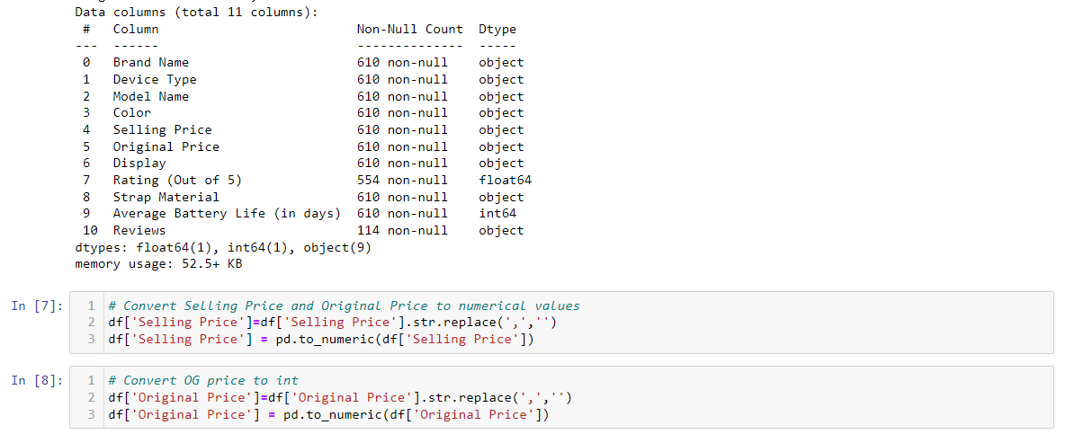

Next, we are going to rename two columns to keep our labeling clear, as well as dropping the ‘Reviews’ columns as it contains too many missing values.

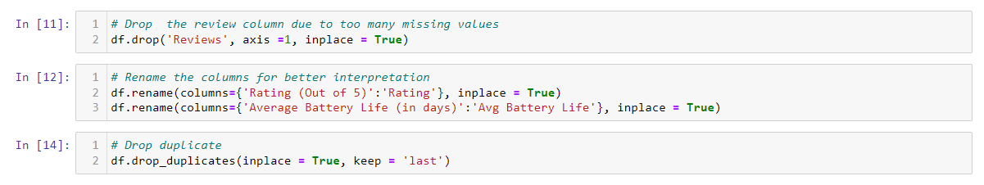

Finally, we impute the missing data in the remaining 55 spots from ‘Ratings’ column and export our newly cleaned CSV file.

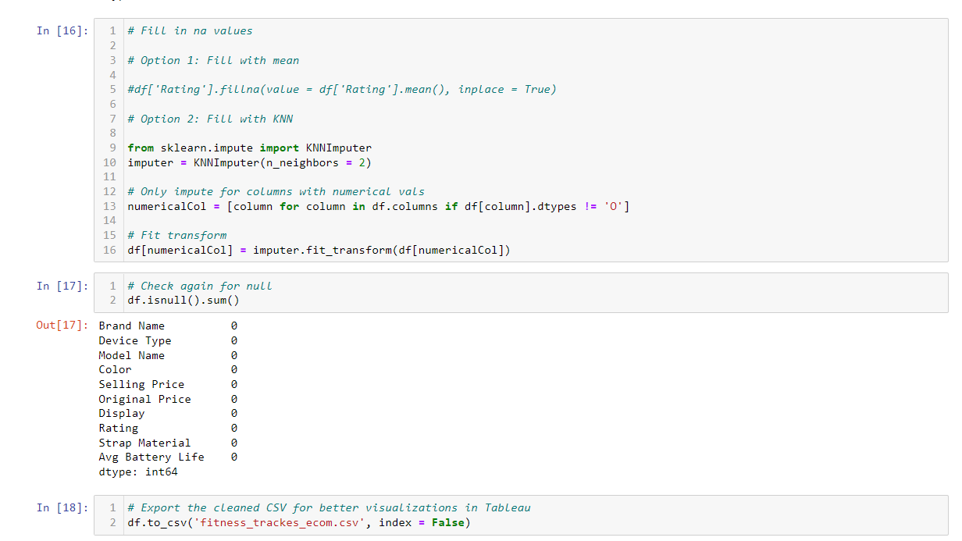

**Graph Details:**

*1st Graph:*

This graph details the average ratings of the top 7 brands. As we can observe, Apple is trailing ahead in this market with nearly 4.6 average rating for their products. Others such as Oneplus, dizo, Fossil or Samsung are also doing very well ratings wise.

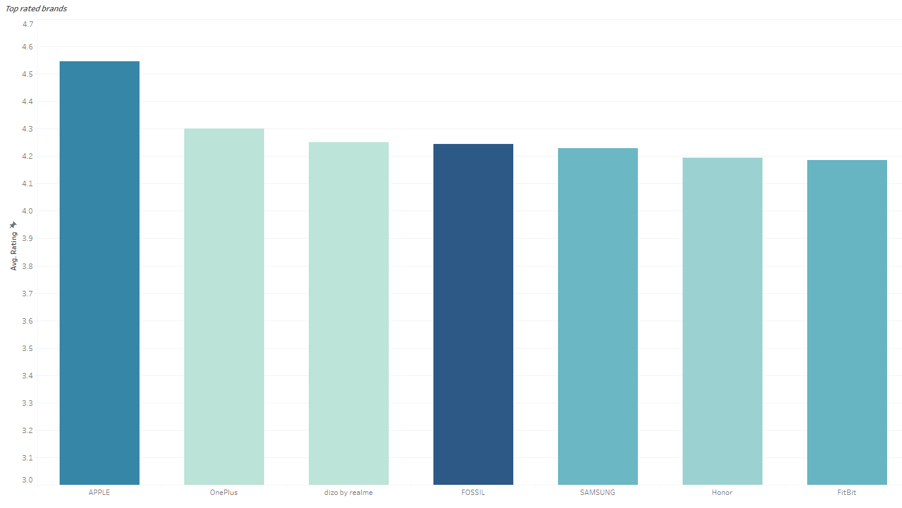

*2nd Graph:*

This graph shows the highest average selling price per device for different brands. From this, we can see that while producing the best rated products, Apple is also the clear leader in terms of selling prices, indicating it’s overwhelming presence in the high-end range. Other competitors such as Garmin and Samsung are not targeting the same price range but rather focus on the mid-tier wearables.

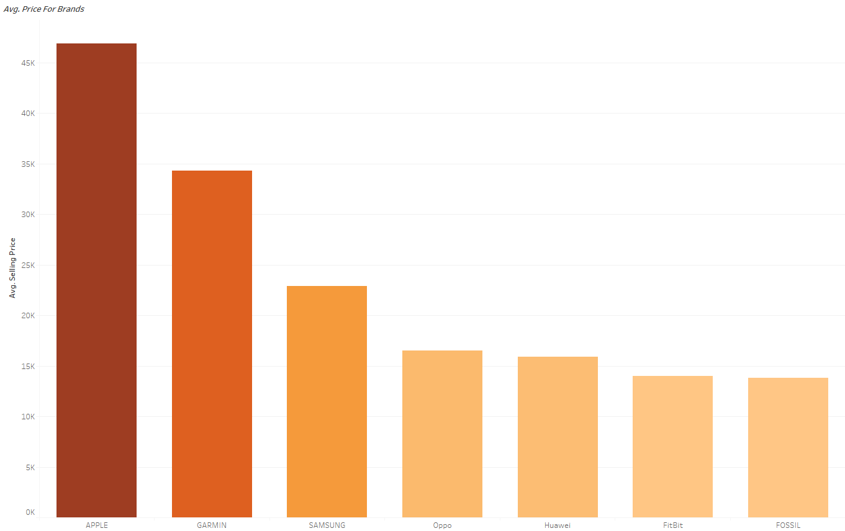

*3rd Graph:*

Finally, we have the graph that shows the market coverage for the top 5 brands. For this particular pie chart, the numbers from the rest of the companies were deemed to be insignificant as their numbers were far quite a bit lower from the top 5. Hence, the percentages might not be the most accurate but it is representative of the overall coverage that these brands have.

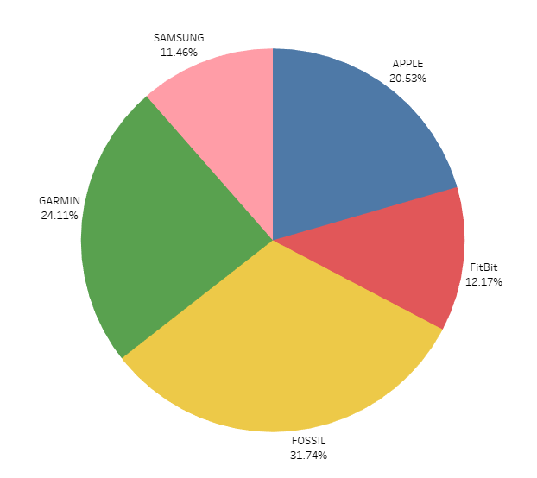

## b. Calories Burnt during Exercises Dashboard - Gouri Nandan Reddy Gangavaram

**Link to public dashboard:** <https://public.tableau.com/app/profile/gouri.nandan.reddy.gangavaram/viz/FitnessActivities_CaloriesBurnt_Dashboard/Fitness_Weight_Ranges_Dashboard>

**Data used**: Calories Burnt by 59 Kgs & 93 Kgs after working out for an hour. The number of Calories burnt per kg for that exercise.

**Data Pre-processing:**

The data columns in this table are in lbs, while the calories per kg are in kgs. So, using Python, I changed the columns to kgs for better comprehension and visualisation. If any null values are identified, the data must be cleaned by eliminating the data entries for consistency. Furthermore, activities are filtered based on our company's needs, as not all activities are important to us. The finished dataset is then saved as a csv file and processed in Tableau for additional display.

**Importing packages used for data pre-processing:**

Here, all the packages required are imported for further using and the input csv data file is read using the python pandas packages “read_csv()”.

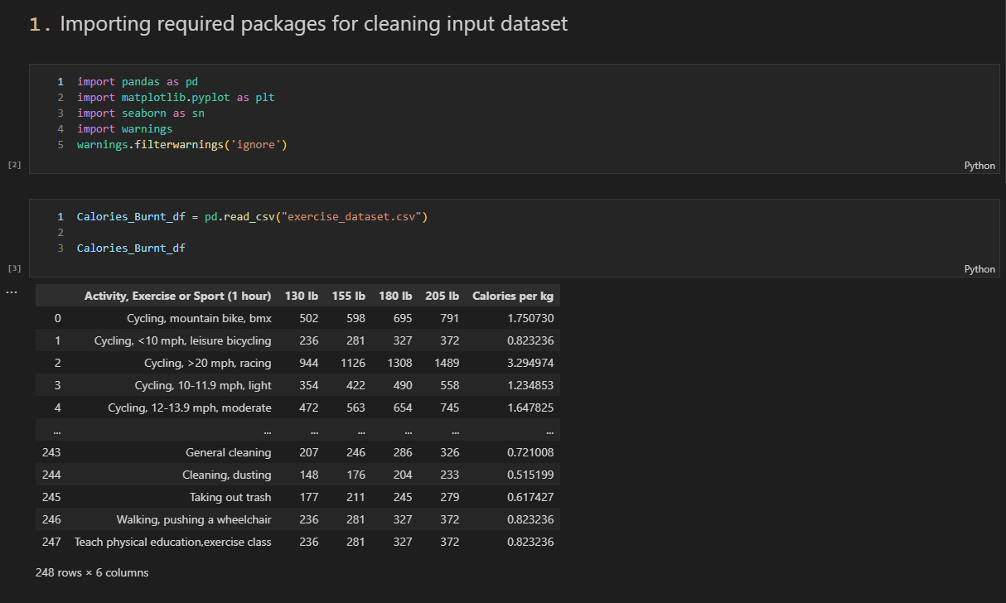

1. **Data Cleaning process:**

Here, the column names are converted from ‘lbs’ to ‘kgs’ for further processing. Then, the data is checked for any Null/NA values as we need to handle them if any found, either by removing that entire row or giving it the mean of the column to keep the integrity of data. Activities are also filtered as per the requirements of our company as below.

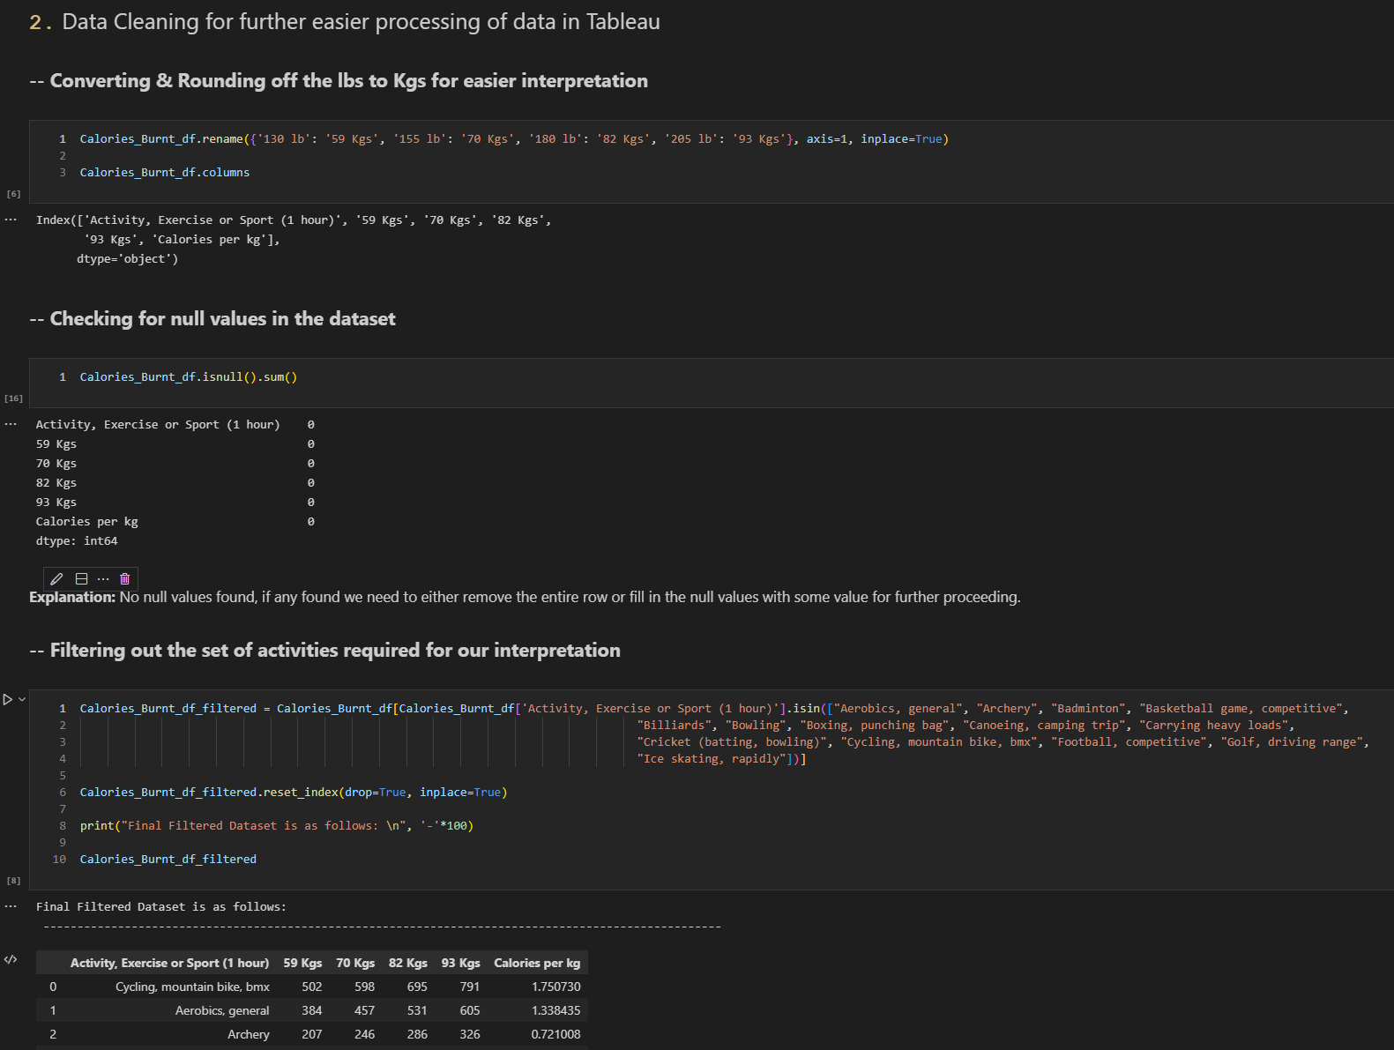

Saving the final csv data into a csv file for that to be imported in Tableau and create visualizations for better understanding of the data for the success of the company.

**Data Visualization in Python – Alternative for Tableau:**

Here, using different python packages such as matplotlib & seaborn data can be visualized into different forms of graphs like bar-plot, pie chart, etc.

Above, visualization represents the number of calories lost per kg on an average between different activities, this could be useful for our company, to identify the best set of activities for different weight groups and implement them in our company as a virtual exercising activity for our company’s success.

**Graph Details:**

*1st Graph:*

The 1st graph illustrates total no. of calories burnt in a hour by a 130lb/59kgs person after doing different activities listed on the x-axis. We can use this analysis to identify the best activity people can perform for losing more calories.

*2nd Graph:*

The 2nd graph illustrates total no. of calories burnt in a hour by a 205lb/93kgs person after doing different activities listed on the x-axis. We can use this analysis to identify the best activity people can perform for losing more calories.

*3rd Graph:*

The 3rd graph illustrates the calories lost /kg for each different activity list below in an hour of performing that said activity overall. This information can be really useful to understand what could possible be the best activity that can be performed for an hour resulting in the most number of calories burnt in an hour.

### c. Fitbit Tracker Data Dashboard – Nithini Bogahawattha

### Audience

The intended audience for this series of visualisations is Jeremy Wellington, a 21-year-old university student and his friends who are keen to maximise their intended fitness goals. They would like to find out more about the fitness trackers. Which could help him to achieve his fitness goals as youngsters.

As they do not have in-depth statistical knowledge. The following questions are the questions which they would like to be answered while looking at the live dashboard:

* Which display would be better when engaging in intense workout?
* What are the famous colours of the devices which are famous among the athletes?
* What is the most affordable Fitbit device according to Jeremy’s budget?
* What fitness tracker has the best average battery life as he is willing to wear the tracker throughout the day?

To answer these questions, he needs the following information:

* Pick two fitness trackers with the highest number of ratings
* Pick the best most famous colour which have been mostly rated among the users.
* Pick two affordable fitness trackers among the Fitbit devices as Fitbit is considered as Jeremy’s favourite brand.
* Pick three fitness trackers which has the best battery life as per the number of reviews which has been gathered.

As a starting point, Jeremy would like to see a range of information about features which are available in each fitness tracker. Jeremy is interested in viewing the visualisations and utilising the interactive dashboard. The dashboard should be professional, engaging, and informative, and should invite further exploration. Ideally, it will evoke feelings of eagerness and of understanding.

**Link to public dashboard:**

<https://public.tableau.com/views/Book1_16601210195790/Dashboard1?:language=en-US&publish=yes&:display_count=n&:origin=viz_share_link>

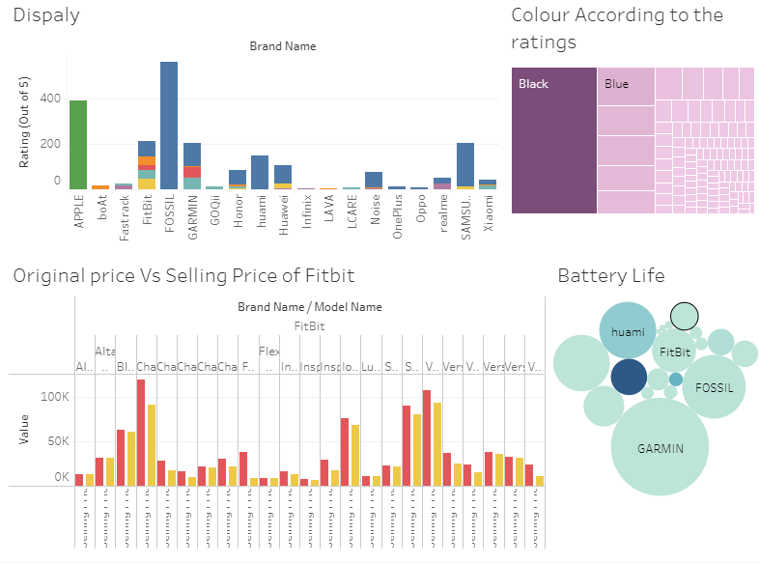

**Graph Details:**

*1st Graph:*

From this graph we will be able to get an idea of the display that most of the brands have used to get a clear image of which display is better for the users according to the ratings. As it is very important because when we are involved in intense workouts there might be a possibility that the display might be damaged.

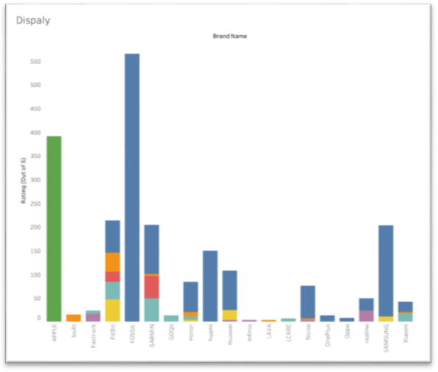

*2nd Graph:*

This graph indicates the colours which have been used in most of the brands. As it will give us an idea of the most famous colour among the users according to the ratings. When it comes to fitness devices colour is considered one of the most important factors as there is a huge possibility that the device will end up getting dirt due to intense workouts and sweat.

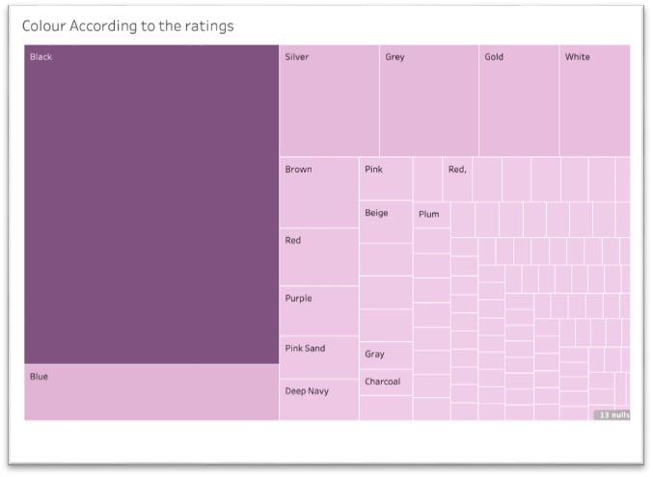

*3rd Graph:*

This graph indicates the difference between the Selling price and the original prices of the Smartwatches of different models in Fitbit. By looking at this graph the customers will be able to get a clear idea of what model is much cheaper in Fitbit according to their budget if they are looking forward to going ahead with Fitbit.

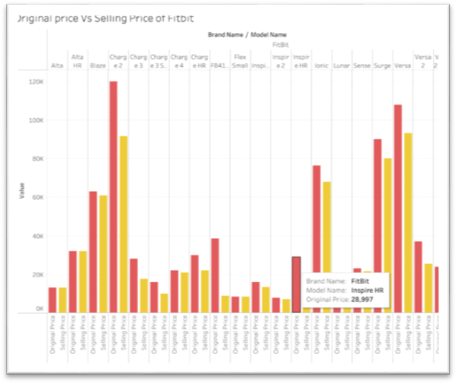

*4th Graph:*

This graph indicates the Average life battery in all the brands according to the number of reviews it has been received. Therefore this will give an idea for the customers in order to decide which fitness tracker would be much worth it.

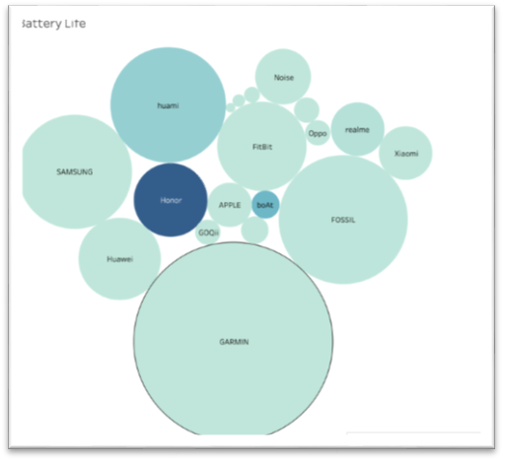

### d. Competitors Popularity Dashboard – Xiaolu Li

**Link to public dashboard:**

This dashboard is designed to analyze the relationship between product details of different brands and their popularity. Showcase details for each brand by correlating the brand's Price, Device type, and Battery life with user ratings.

**Link to public dashboard:**

<https://public.tableau.com/views/fitness_trackers_dashboard/1?:language=zh-CN&:display_count=n&:origin=viz_share_link>

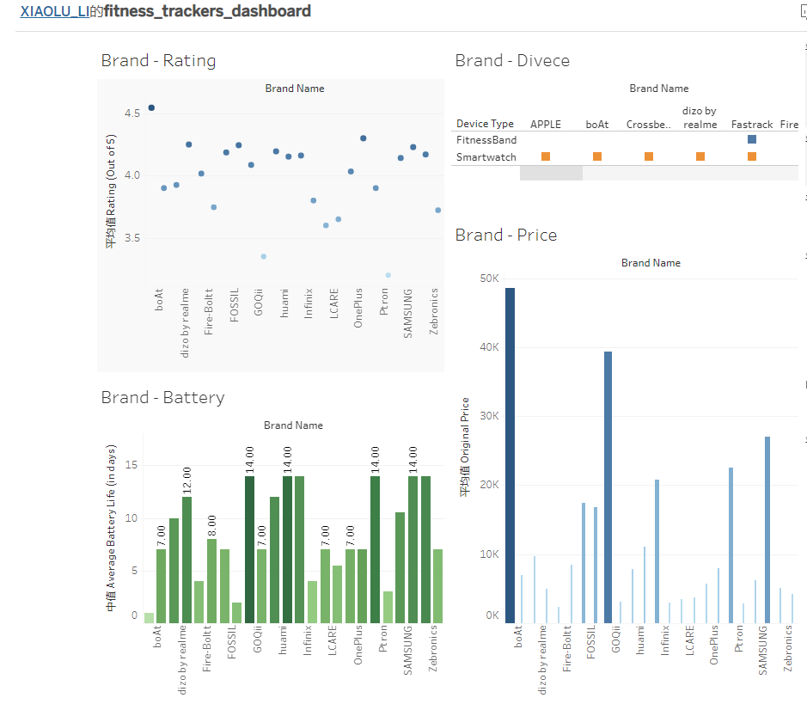

**Data Pre-processing:**

Process raw data through python to understand data type, content, and labels. Handle data null issues, same string, and data format. This processed data is more convenient when using tableau.

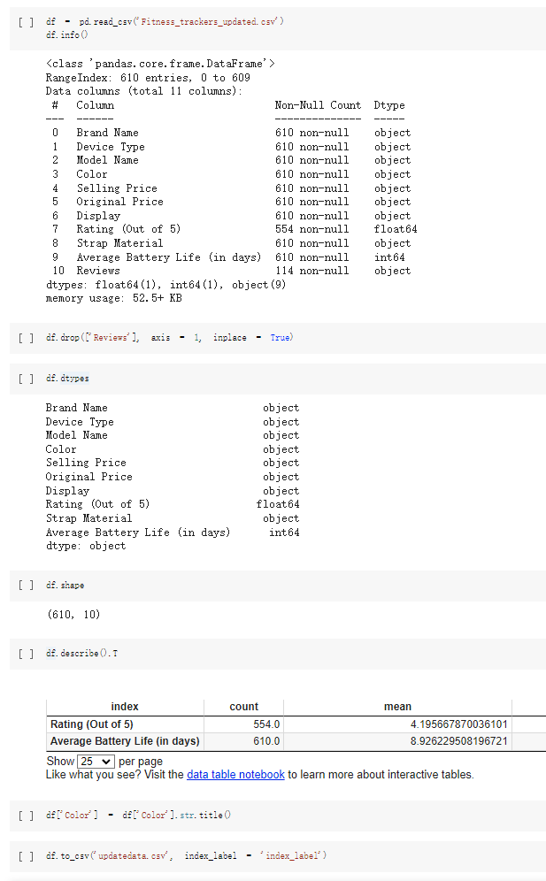

**Graph Details:**

*1st Graph:*

The size of the blue dot represents the average rating of the brand, and the darker the color, the higher the average rating of the brand. Looking at the chart, I can see that Apple has the highest average rating, followed by OnePlus.

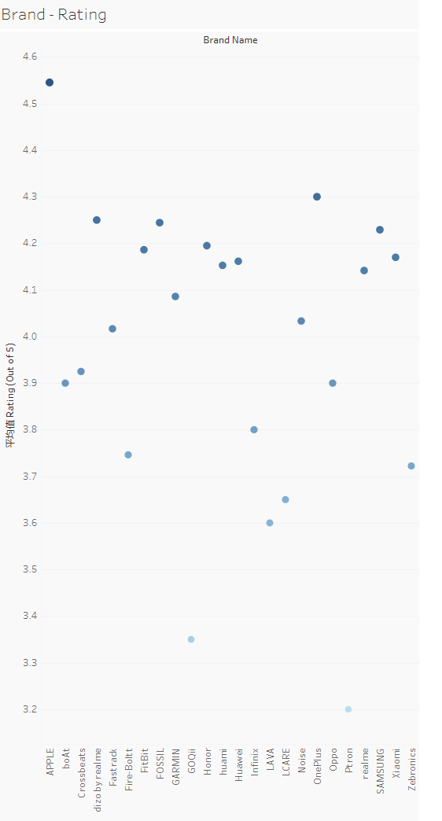

*2nd Graph:*

The height of the bar in the figure represents the average original price of each brand, and the original price shows the difference in the original price more clearly through the difference in the width of the bar. Darker bars indicate higher selling prices. The average value of Apple's original price and selling price is the highest among all brands. The relatively low original price and selling price of OnePlus, which has high user ratings, may also be one of the reasons for its user satisfaction.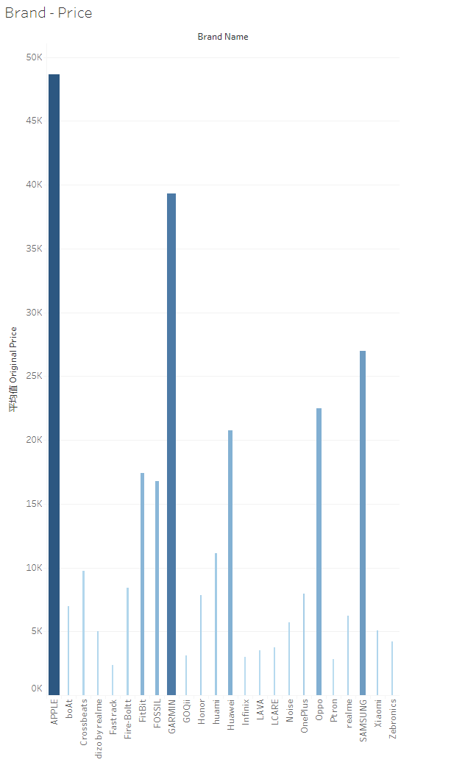

*3rd Graph:*

The chart in Chapter 3 shows the types of device types owned by each brand. For example, Apple only has a watch, while FitBit has both a watch and a band.

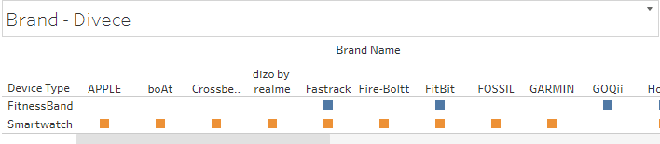

*4th Graph:*

Battery life is also a common concern for users. Darker bars represent better battery life.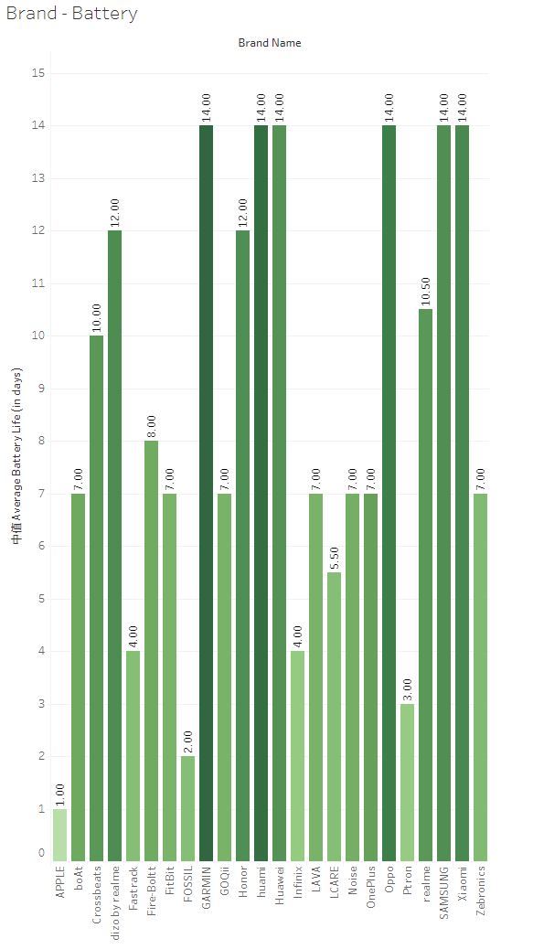

## e. Rating Factors Dashboard – Anh Quan Hua

**Aim of the dashboard:**

This dashboard aims to provide an informative summary on the attributes that, potentially, have the greatest effect on user experience with smart wearables. The measurement for end-users’ satisfaction being used here is “Rating”, particularly for most case, the average ratings for each category being examined.

**Link to the public dashboard:**

<https://public.tableau.com/app/profile/quan.h5693/viz/RatingFactorsDashboard/RatingDashboard>

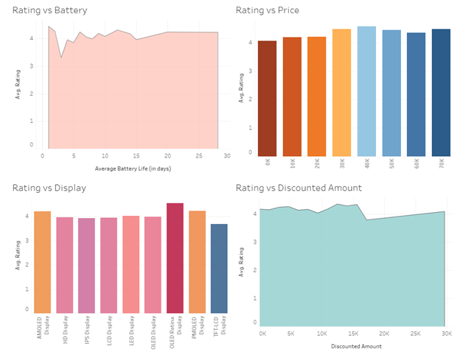

**Data used:**

<https://www.kaggle.com/datasets/devsubhash/fitness-trackers-products-ecommerce>

**Data Pre-processing:**

Please refer to the data pre-procession section of the Top Competitors Overview Dashboard to gain full details to the process of cleaning the data. The same data produced in that part is used for this dashboard.

**Graph Details:**

*1st Graph:*

The first graph is a bar chart containing price bins and the average ratings for that particular price range. Overall, we can see that there is a definite different from bins (0 to 10k), (10 to 20k) and (20 to 30k) to the higher range bins. This either suggests that users tend to rate the more expensive devices better, or that the budget and entry-level wearables simply have to many caviats.

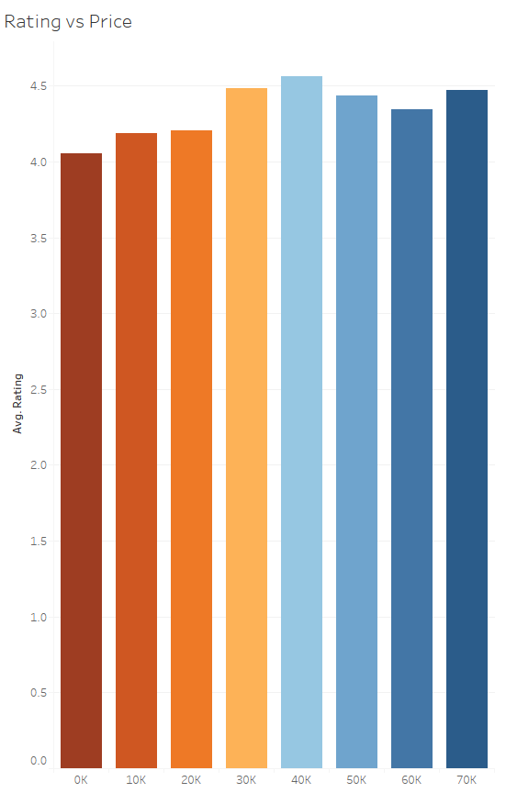

*2nd Graph:*

This graph shows the average ratings for each type of display being used for smart devices. Since these wearables are so small and are designed to be used when exercising, display is a crucial factor in the overall user’s experience. In summary, we see that the large majority prefer OLED Retina display the most, followed by AMOLED and POLED displays.

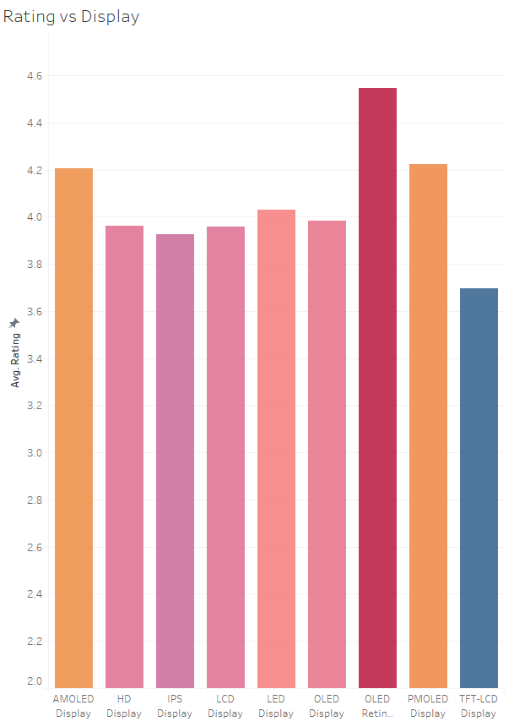

*3rd Graph:*

After examining the correlation between Price and Ratings, it might be worth it to examine the relationship between Discounted Amount and Ratings as well. This graph details the average rating progression/distribution when we are looking at the discounted amount for each device. The discounted amount is calculated by taking the Original Price minus the Selling Price. Overall, we can see a soft linear progression 0 up to 15,000 rupees discounted and after that the behavior is unclear.

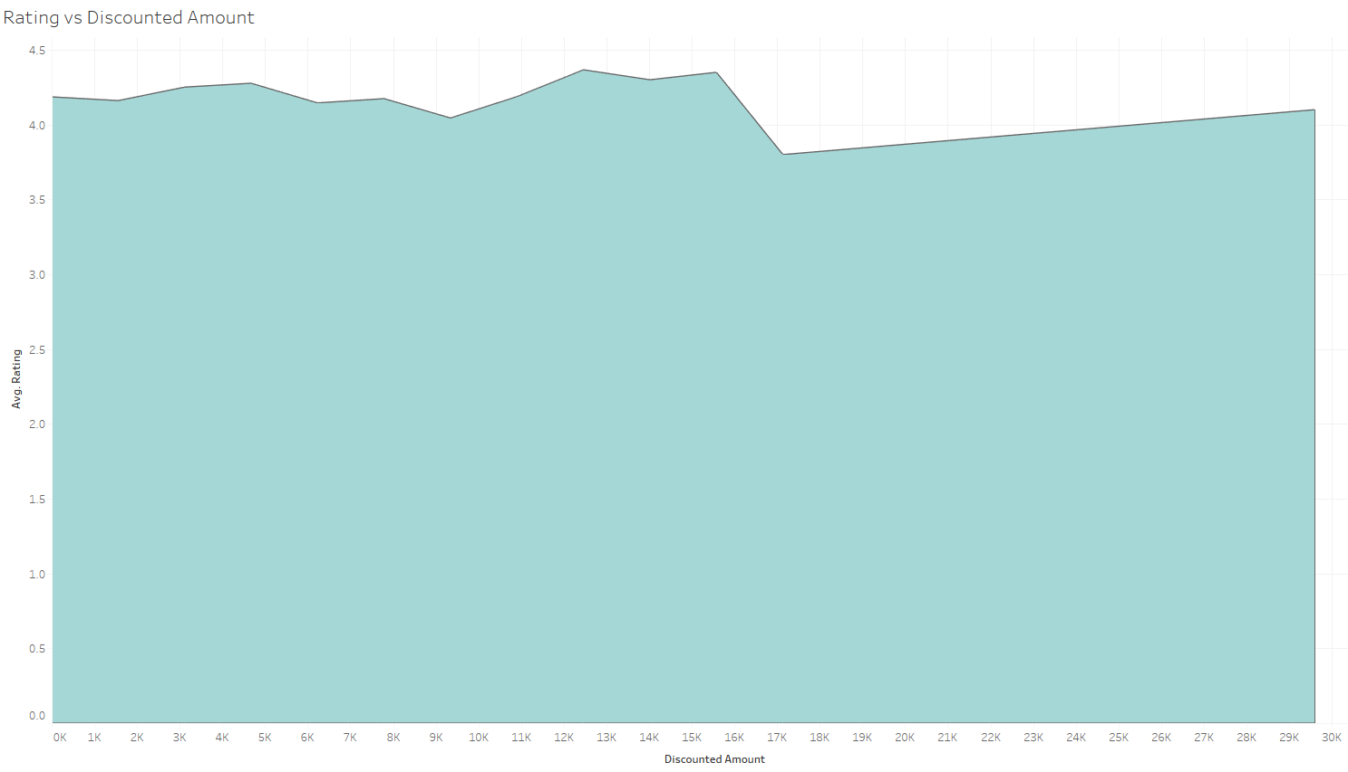

*4th Graph:*

Finally, we have a line graph that helps us visualize how users rating are correlated with battery life. In this case, the batter life data being collected is directly taken from the manufacturers’ product descriptions and the unit for them is day. This one seems to produce the most noticeable pattern in terms of correlation – assuming that we ignore the abnormally high ratings at 1-2 days of battery (which is likely due to the Apple’s Watch existence). We can clearly see that the ratings gradually went up from 3 days up to 28 days – indicating that users do care a lot about battery for their fitness tracking devices.

